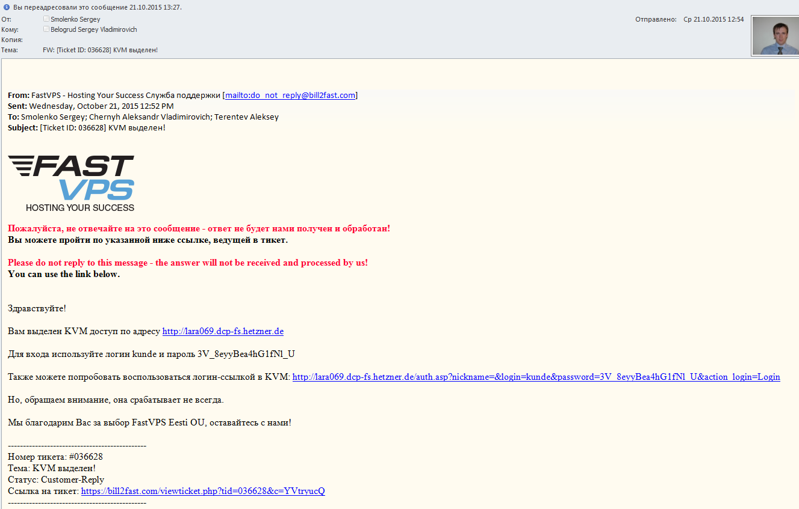

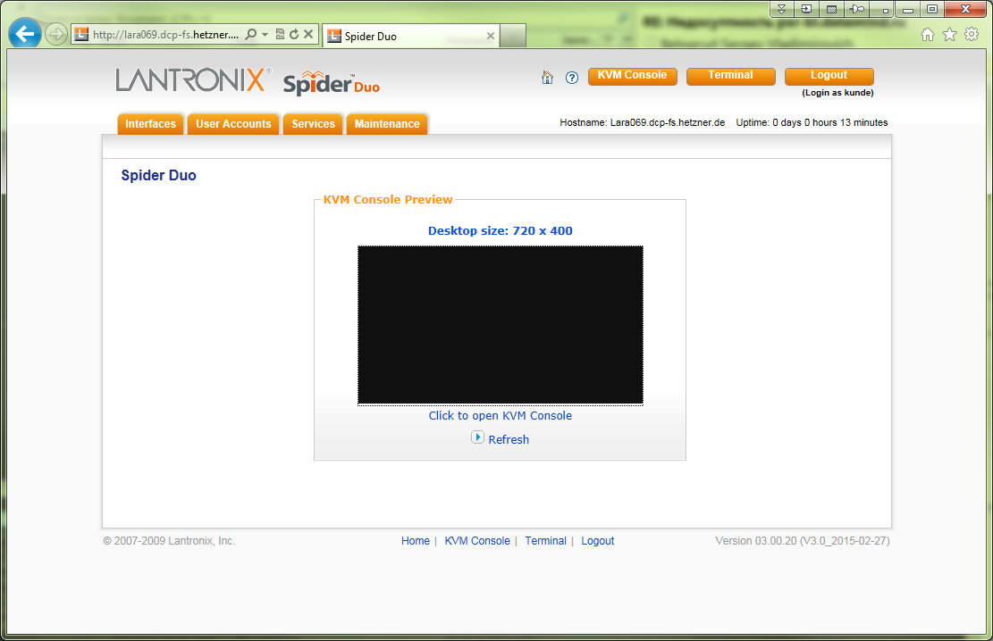

# To get access to KVM console it should be present java workstation and allowed access to specified host in letter host and port 443 (in this example lara069:443).
# At this moment there are no available to get access from our workstation to random hosts and https port 443.

